FOR IMMEDIATE RELEASE

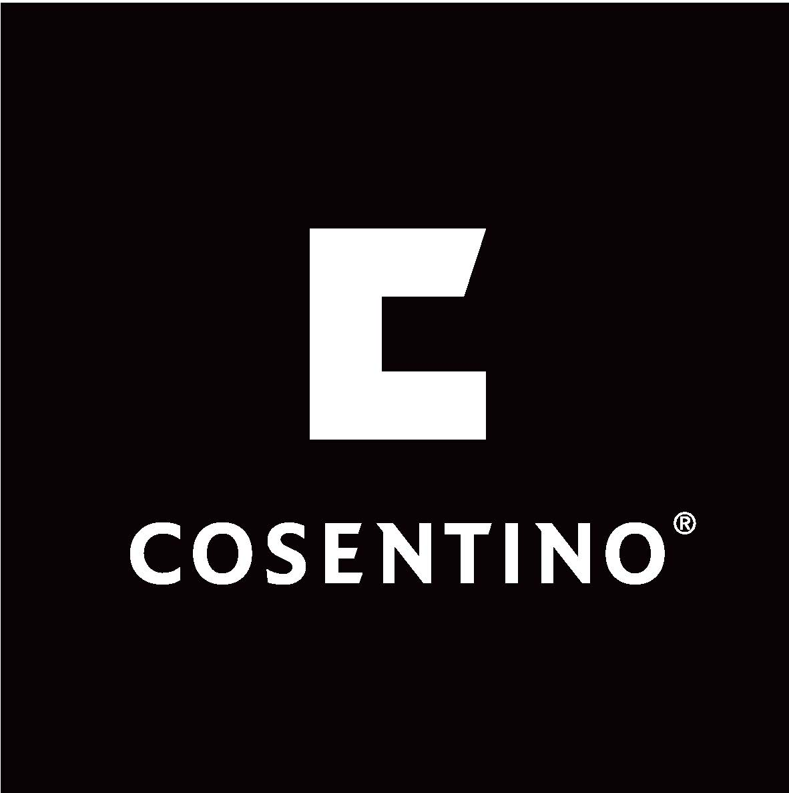
Media Contact:

Erin McKay, Flying Camel
O: (519) 756-2709, ext.: 226
M: (416) 455-9960

E: erin@flyingcamel.com

COSENTINO WINS BEST BOOTH AWARD 601-SQ. FT AND ABOVE AT THE INTERIOR DESIGN SHOW
Renowned design firm, Cecconi Simone designed award-winning booth inspired by unique surface design

TORONTO, ON (January 24, 2017) – Cosentino, a global leader in the production and distribution of innovative surfaces for the world of architecture and design, has won first place in the 601-sq. ft. and above category at the 2017 Interior Design Show Booth Awards held this past week in Toronto. Juried by an esteemed group of judges, the IDS Booth Awards recognizes excellence in exhibit design.
Cosentino enlisted internationally acclaimed Canadian design firm Cecconi Simone for the award-winning design. The first-place booth inspired design professionals with its contemporary urban town home layout, designed using unconventional surface applications. Nearly the entire booth was fabricated using new releases and prototypes of both ultra-compact Dekton and Silestone natural quartz surfaces.

“Cecconi Simone is honoured to be recognized with this award at IDS. Cosentino's commitment to innovative product design is reflected in the booth which showcases Dekton and Silestone in unconventional and unexpected ways like furniture, counters, floors and walls adaptable to the interior and exterior. Its purpose is to inspire designers, architects and consumers to see the limitless possibilities and show how surfaces can be used in day to day settings,” said Anna Simone, founding partner of Cecconi Simone.

The exhibit featured an outdoor inspired dining area using Dekton’s newly released Trilium, the brand’s first recycled colour option which captures the visual texture and colour variation of aged and oxidized stainless steel. Other areas of the exhibit displayed Silestone’s new Eternal Collection which was shown for the first time in Canada at IDS.

Cosentino and Cecconi Simone have a successful history of collaboration. In 2016 the firm designed the IDS booth in the form of an art gallery setting meant to inform the architecture and design community on the unique properties of Dekton. “Dekton is the surface material of the 21st century and through last year’s exhibit, we were able to showcase how we could achieve unique one-of-kind designs - through printing and etching - working solely with the material to create an environment,” added Simone. The entire booth was created using Dekton, demonstrating just how dynamic and cutting-edge the product truly is. The 2016 IDS booth earned a silver best Booth Award at IDS.

Cecconi Simone took the next Cosentino exhibit space one step further when they designed the ‘Cosentino City’ for Milano Design Week at Salone Del Mobile. Through four vignettes, Cecconi Simone created a Parisian Apartment, a Balinese Garden, a London Loft and a Toronto Town Home, all illustrating the dynamic use of Cosentino products in curated urban and rural spaces.

“IDS is considered one of North America’s leading design shows, so we’re thrilled that Cosentino was selected first place for the Booth Awards. We truly feel that we have selected the best firm in Cecconi Simone time and time again to interpret our innovation and design when it comes to our award-winning exhibits. Winning this award sets the bar high for the Canadian market and we’re excited to see what the rest of 2017 has in store,” said Patty Dominguez, VP of Architecture & Design Sales for Cosentino North America.
For additional information, high res. Images or to arrange an interview with a spokesperson from Cosentino, please contact Erin McKay at: erin@flyingcamel.com. Any press inquiries related to Cecconi Simone, please contact Darlene Hesas at: dhesas@cecconisimone.com.

About Cosentino Group:
Cosentino Group is a global, family-owned company that produces and distributes high value innovative surfaces for architecture and design. As a leading company, Cosentino imagines and anticipates together with its customers and partners design solutions that offer value and inspiration to peoples’ lives. This goal is made possible by pioneering brands that are leaders in their respective segments such as Silestone®, Dekton®, and Sensa by Cosentino®. Technologically advanced surfaces create unique designs for the home and public spaces.

The group bases its development on international expansion, an innovative research and development program, respect for the environment and sustainability, and its ongoing corporate commitment to society and the local communities where it operates, education, equality and health & safety.

Cosentino Group currently distributes its products and brands in more than 80 countries from its headquarters in Almeria, Spain. Currently Cosentino is present in 32 countries with its own assets in 27 of them. The group has seven factories (six in Almeria and one in Brazil), one intelligent logistics platform in Spain and more than 120 commercial and business units throughout the world. More than 90% of Cosentino Group’s financial turnover comes from international markets. Cosentino has four centres in the Canadian market, created for exclusive display, distribution, education and service in Quebec, Toronto, Calgary and Vancouver. www.cosentino.com

Cosentino Canada Newsblog: http://canada.cosentinonews.com/

Media Contact: For more information, please contact Erin McKay at Flying Camel: (416) 455-9960 or via email erin@flyingcamel.com

-30-

