FOR IMMEDIATE RELEASE
Media Contact:
Flying Camel
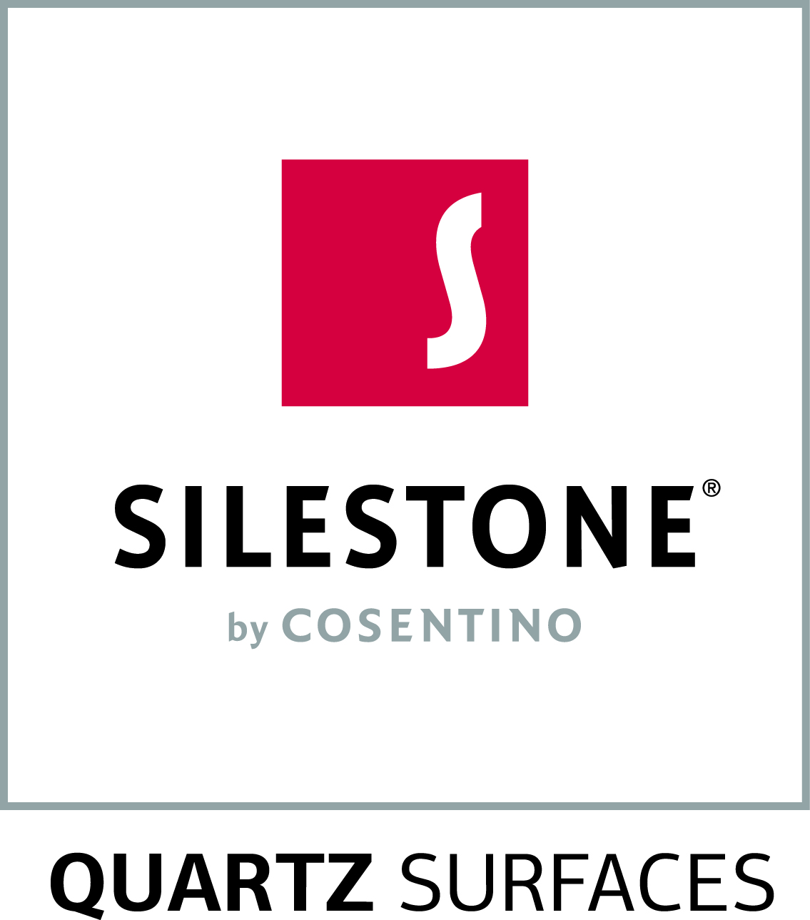
Erin McKay
T: (519) 756-2709
M: (416) 455-9960
E: erin@flyingcamel.com

New Silestone by Cosentino colour additions ideal
for Canadian design aesthetic
World leader in quartz surfaces launches two new white colours inspired by natural marble

TORONTO, ON (November 1, 2016) – Silestone, the world leader in quartz surfacing, introduces two new colours bringing its total colour offerings to over 60 options available across Canada. Inspired by beautiful natural marble, White Arabesque and Snowy Ibiza are the latest colour additions to join Silestone’s natural quartz Custom Series.

Acknowledging the clean white design aesthetic permeating Canada’s interior design market, these two new colours feature delicate grey veining set amongst subtle elegant white hue backgrounds. Silestone is committed to continuously designing new colours to meet the needs of Canada’s architecture and interior design community. These new colours can be used for countless design applications including countertops, flooring, interior wall cladding, with the same maintenance benefits as of any Silestone product.

Left: Snowy Ibiza boasts dark, fine, elegant veining on a luminous white background making this colour the perfect alternative to classic, understated marble.
Right: White Arabesque embodies an impactful grey veining set against a vivid off-white backdrop mimicking the lively look of natural marble.
“Natural stone is a timeless design staple that has been around for centuries. These new colour offerings are a great alternative for anyone looking to achieve the natural marble look with the added benefits that Silestone natural quartz offers,” said Lorenzo Marquez, VP of Marketing for Cosentino North America.
As with all Silestone products, White Arabesque and Snow Ibiza are naturally non-porous and never need to be sealed. These surfaces are easy to clean and have high scratch, stain and heat resistance. Silestone also offers the assurance of GREENGUARD certification for clean air quality, and the National Sanitation Foundation certification (NSF 51) for safe food preparation.
Silestone retails from $43 to $127 per square foot, depending on colour, thickness and finish. It is available at kitchen and bath dealers and home improvement centers nationwide. Silestone offers a 25-year limited transferable manufacturer’s warranty. For more information, visit ca.silestone.com

-30-

About the Cosentino Group:
The Cosentino Group is a global, family-owned company that produces and distributes high value innovative surfaces for architecture and design. As a leading company, Cosentino imagines and anticipates together with its customers and partners design solutions that offer value and inspiration to people’ lives. This goal is made possible by pioneering brands that are leaders in their respective segments such as Silestone®, Dekton® and Sensa by Cosentino®. Technologically advanced surfaces, which allow the creation of unique designs for the home and public spaces. The group bases its development on international expansion, an innovative research and development program, respect for the environment and sustainability, and its ongoing corporate commitment to society and the local communities where it operates, education, equality and health & safety. The Cosentino Group currently distributes its products and brands in more than 80 countries, from its headquarters in Almeria (Spain). Currently Cosentino is present in 32 countries, with its own assets in 27 of them. The group has 7 factories (6 in Almería (Spain and 1 in Brazil), 1 intelligent logistic platform in Spain, and more than 120 commercial and business units throughout the world. More than 90% of Cosentino Group’s financial turnover comes from international markets. Cosentino has four centres in the Canadian market, created for exclusive display, distribution, education and service in Quebec, Toronto, Calgary and Vancouver. www.cosentino.com

Cosentino Newsblog: http://canada.cosentinonews.com/

Media Contact:
For more information, please contact Erin McKay at Flying Camel: (416) 455-9960 or erin@flyingcamel.com

