FOR IMMEDIATE RELEASE
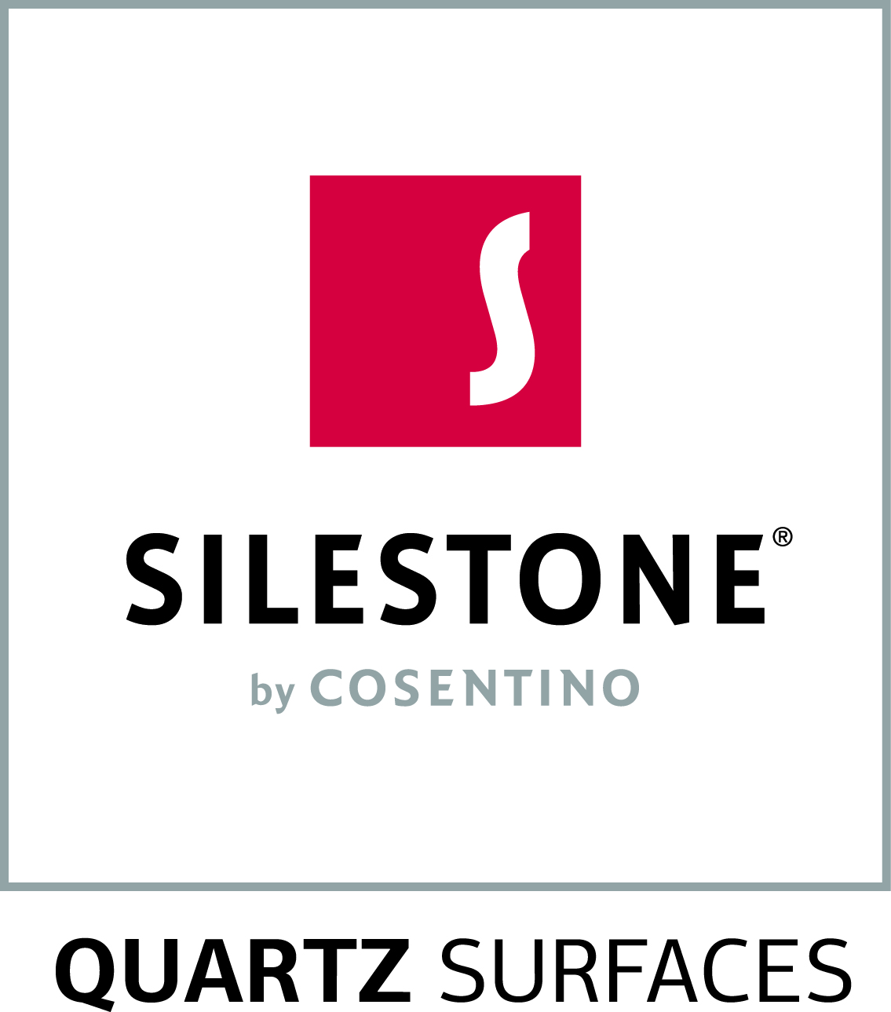
Media Contact:
Erin McKay, Flying Camel
O: (519) 756-2709, ext: 226
M: (416) 455-9960
E: erin@flyingcamel.com

SILESTONE CREATES ICONIC WHITE; TAKES POPULAR PALETTE TO NEXT LEVEL
Introducing the purest and brightest white colour quartz surface available to market

TORONTO, ON (November 22, 2016) – Silestone, the world leader in quartz surfacing, launches Iconic White, the purest, lightest and brightest white hue currently available on the market for quartz materials.

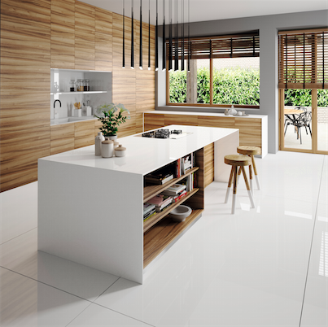
Building on Silestone’s success of its White Zeus and White Zeus Extreme colours, two of the best-selling colours in the brand’s history, Iconic White takes popular white quartz to the next level with its unparalleled vibrant, refined and luminous appearance.
White, often an integral and essential part of modern design, embraces clean, uncluttered spaces. Iconic White provides an even purer white than its predecessors with a myriad of applications across residential and commercial applications, as well as hospitality settings, including kitchen countertops, vanities, bar tops, wall cladding and more.

Developing a colour with such an extraordinary degree of whiteness required significant innovation from the Cosentino Research and Development team to not only ensure its aesthetic, but the durability that makes it a category leader.

“Iconic White is for designers, architects and homeowners looking for the ultimate sleek, modern appearance in their projects, coupled with durability only Silestone can offer,” says Lorenzo Marquez, VP of Marketing for Cosentino North America. “Solid white surfaces will always be in demand and we are especially thrilled to have pushed Silestone’s innovation to a new level with Iconic White.” As with all Silestone natural quartz products, Iconic White is virtually non-porous and never needs to be sealed. It is easy to clean and has high scratch, stain and heat resistance.

Silestone offers a variety of other white alternatives including: White North and White Storm. Both shades present a finish with tiny, elegant flecks of gray. Blanco Maple is another beautiful option, mottled with tiny flecks of quartz and glass, creating subtle and attractive flashes of light. Different only in composition, all of these provide, to a greater or lesser degree, a white finish based on light, spaciousness and purity.

Silestone retails from $49 to $110 per square foot installed, depending on colour, thickness and finish. Iconic White is available in thicknesses of 1.2cm, 2cm and 3cm at kitchen and bath dealers and Cosentino Centres nationwide. Silestone quartz offers a 25-year limited transferable manufacturer’s warranty. For more information, visit ca.silestone.com

About Cosentino Group: Cosentino Group is a global, family-owned company that produces and distributes high value innovative surfaces for architecture and design. As a leading company, Cosentino imagines and anticipates together with its customers and partners design solutions that offer value and inspiration to peoples’ lives. This goal is made possible by pioneering brands that are leaders in their respective segments such as Silestone®, Dekton®, and Sensa by Cosentino®. Technologically advanced surfaces create unique designs for the home and public spaces.

The group bases its development on international expansion, an innovative research and development program, respect for the environment and sustainability, and its ongoing corporate commitment to society and the local communities where it operates, education, equality and health & safety.

Cosentino Group currently distributes its products and brands in more than 80 countries from its headquarters in Almeria, Spain. Currently Cosentino is present in 32 countries with its own assets in 27 of them. The group has seven factories (six in Almeria and one in Brazil), one intelligent logistics platform in Spain and more than 120 commercial and business units throughout the world. More than 90% of Cosentino Group’s financial turnover comes from international markets. Cosentino has four centres in the Canadian market, created for exclusive display, distribution, education and service in Quebec, Toronto, Calgary and Vancouver. www.cosentino.com

Cosentino Canada Newsblog: http://canada.cosentinonews.com/

Media Contact: For more information, please contact Erin McKay at Flying Camel: (416) 455-9960 or via email erin@flyingcamel.com

