New Honorary Ambassadors for the Spain Brand
The Leading Brands of Spain Forum (FMRE), in collaboration with the Office of the Government High Commissioner for the Spain Brand, through a panel of judges made up of representatives from business, institutional and international fields, chaired by Antonio Abril Abadin, Director and Secretary of the Board of Directors of Inditex and Deputy Chairman of the Forum, has appointed the new Honorary Ambassadors of the Spain Brand (EHME). This is the seventh edition of the awards, which aim to publicly acknowledge individuals, businesses and institutions which have most and best contributed, through their exemplary professional careers, to strengthening the positive image of Spain abroad. The Committee met at the Hotel Barceló Atenea Mar in Barcelona on Friday 14 October.
This acknowledgement is granted in seven categories on a biennial basis, with the approval of the Ministry of Foreign Affairs and Cooperation. The new Honorary Ambassadors of the Spain Brand are: Francisco Martinez Cosentino (Business Management), Andres Iniesta (Sports), Gabriel Escarrer (Tourism and Gastronomy), Sara Baras (Culture and Communication), the Elcano Royal Institute (Institutional Relations), Obra Social "La Caixa" (Social Action) and Juan Ignacio Cirac (Science and Innovation).
The accreditation ceremony of the seventh edition of Honorary Ambassadors of the Spain Brand will take place next year and it is expected, as in previous editions, to be presided over by Their Majesties the King and Queen of Spain.

CATEGORY | EHME | GROUNDS FOR ACKNOWLEDGEMENT
Business Management: FRANCISCO MARTÍNEZ COSENTINO | 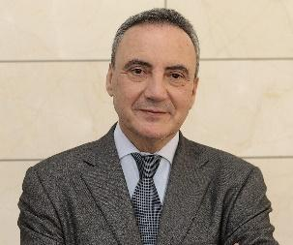 | As one of the Spanish entrepreneurs with the greatest international and innovative vocation, he has converted the Cosentino Group into an epitome of international success and made it a world leader in the field of architecture and design. An outstanding figure in the field of internationalisation, Francisco Martinez-Cosentino was awarded the Medal of Andalusia (1992) and the Medal of Merit for Work (2016).
Sports: Andres Iniesta | 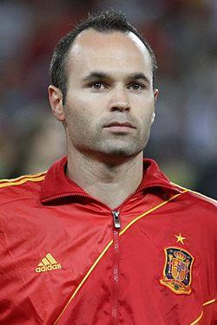 | Recognised and respected both in Spain and all over the world, by merit of being one of the best football players and Spanish athletes in history. He has won all the top national and international trophies, with both Barcelona Football Club and with the Spanish National Team. In addition to his talent and sporting success, the jury acknowledges his sense of humility and great human values which make him a superb Ambassador for the Spain Brand.
Tourism and Gastronomy: GABRIEL ESCARRER | 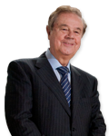 | Chairman and founder of the Meliá Group, he has been one of the pioneers in international expansion in the Spanish hotel sector, making the Meliá brand an excellent ambassador for Spanish tourism worldwide. He has received numerous awards, which highlight his outstanding contribution to the world of the domestic and international hospitality industry. At present Meliá Hotels has more than 370 hotels located in 43 countries on 4 continents, making it one of the world's largest holiday hotel companies.
Culture: Sara Baras |  | As one of the most renowned and internationally recognised Spanish artists, she has performed on the main stages of Europe, the United States, Latin America and Asia. She was awarded the National Dance Award in 2003, the Gold Medal of Andalusia (2004) and Grande Medaille de Vermeil of the City of Paris (2009).
Institutional Relations: Elcano Royal Institute | 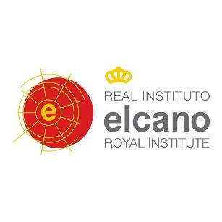 | As a pioneer in the field of the analysis of the image of Spain and its promotion, this is certainly one of the most prestigious and important think-tanks in Spain and a benchmark of great international influence. According to the think-tank ranking published annually by the University of Pennsylvania, the Elcano Royal Institute ranked 30th in the category of "Foreign Policy and International Relations" and 19th in the top think-tanks of Western Europe.
Social action:  OBRA SOCIAL "LA CAIXA" | 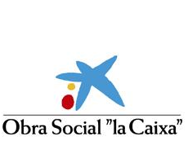 | For their great work in support of activities and projects of an educational, cultural and scientific nature, not only in Spain, but also in more than twenty countries in Latin America, Asia and Africa, where their commitment to work on behalf of children is outstanding. With its 500 million euro budget, "La Caixa" is the leading private foundation in Spain and one of the most important in the world. Every year it is the driving force behind more than 46,000 initiatives benefitting more than 9.9 million people.
Science and Innovation:  JUAN IGNACIO CIRAC |  | As one of the most internationally renowned Spanish scientists, specifically in the field of physics, he is acknowledged for his research in computation and quantum optics. Since 2001 he has been the Chairman of the Theory Division at the Max Planck Institute of Optics in Germany. He received the Prince of Asturias Award for Scientific and Technical Research (2006), the BBVA Foundation Frontiers of Knowledge Award (2008), among many other recognitions of his work.

